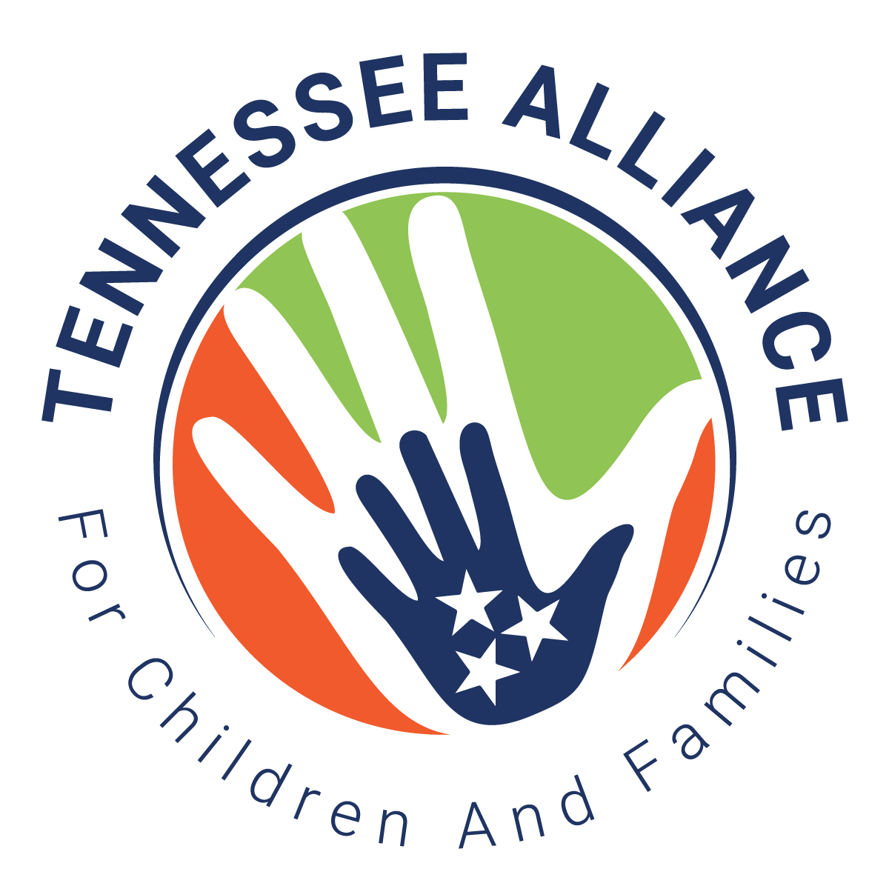

Phil Acord was a champion of child well-being in the state of Tennessee for 50 years and a valued member of the Tennessee Alliance for Children and Families. He dedicated his career to strengthening services for children, families, and communities in our state.

Purpose of the Phil Acord Award
The Tennessee Alliance for Children and Families wishes to recognize leaders, innovators, and outstanding professionalism in the child welfare arena. The award is to recognize significant contributions made over time to Tennessee’s children and families, or a single impactful contribution that will have a far-reaching and long-lasting positive impactful contribution that will have a far reaching and long-lasting positive impact on the quality and/or scope of services.

The award also honors those who work with colleagues and professional organizations in a manner that inspires leadership abilities in others or improve service delivery in child welfare.

Nominee

Agency

Nominated By

Date

Please Attach
Specific detailed contributions your nominee has made to Tennessee’s Child Welfare system. Please also include additional information as appropriate, such as date of contribution, programs developed and/or affected, and outcomes.

Please forward this nomination to Darci L. Halfman, Executive Director of the Tennessee Alliance for Children and Families at dhalfman@tnchildren.org.

Three finalists will be chosen by the Membership Committee of TACF. The final award recipient will be chosen by the Executive Committee of TACF.

