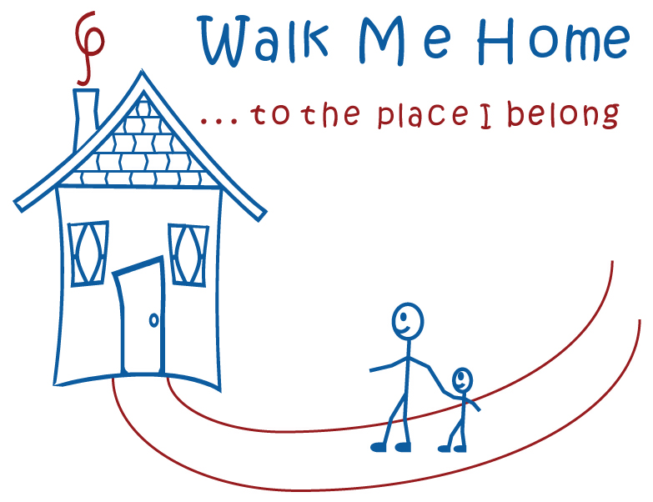

Hello Resource Parents of Tennessee,

It is indeed an honor and a pleasure to announce the 5th annual “Walk Me Home…to the Place I Belong” event for the 2012 walk season.

We here in Tennessee will be enjoying the events in the four (4) Grand Regions again this year.

* Middle TN – May 19th at the Bicentennial Mall in Nashville at the foot of the State Capital,
* Memphis-Shelby County – August 11th at Shelby Farms,
* Chattanooga – at the River Park on September 8th and,
* Knoxville – on October 6th, 2012.

Each one of these great events has in years past been exciting to plan and execute but most of all to experience. All events offer fun for folks of all ages. In the past, we have enjoyed support from both the child welfare system as well as community partners. It has helped us to raise awareness and shed a positive light on the fostering experience both for children and families.

As you know in this time of tight budgets, anything that we can do to support children in foster care is greatly needed. With the walk events in years past the Walk Me Home “Enrichment Fund” has been able to provide for hundreds of children statewide.

In our beginning years we were able to provide book bags and school supplies for children across the state. We have expanded since those days due to our aggressive fundraising efforts. We are now able to provide camps and band instruments, as well as durable equipment including therapeutic tricycles, asthma breathing equipment, scholarships for graduates, help with start up support for children aging out…and the list goes on.

We are asking for your support by joining us here in Middle TN on May 19th. This year’s event is going to be even more exciting than ever with the addition of our featured guest, Grammy Award Winning country music singer/songwriter Emmylou Harris, singer/songwriter Jaime Fox, our own Rutherford County singer/songwriter JT Cooper and the performance of some our children in care that have helped to compose and record a new song with Jaime, the author of the Walk Me Home soundtrack.

Another new addition is the sponsorship commitment from Nashville Shores. Nashville’s most popular water park is in the process of finalizing their complete sponsorship package which will include a Walk Me Home Day on that Saturday that will give discounted tickets to the park! How exciting!!!!!!

It will be a day that is filled with fun, food and fellowship. However, most importantly, it will afford participants the opportunity to be a part of something that will continue to grow and benefit our children not only here in Middle Tennessee but also statewide.

If you would like to know more about the Walk Me Home Enrichment Fund please go to the TFACA website, read the protocol and download the application if you have a child with a need. Look on the facebook pages of local associations as well as the Department.

We need you to come out and join us, so please sign up a team to walk by visiting our website at [www.firstgiving.com/walkmehome/event/Nashville](http://www.firstgiving.com/walkmehome/event/Nashville). 80% of the proceeds stay here in Tennessee and the more we participate the more we can do for children in Tennessee.

We look forward to seeing you so come out and LET’S WALK!

Dorsell Martinez

State Coordinator

Walk Me Home 2012